**Ideation Phase**

**Define the Problem Statements**

|  |  |
| --- | --- |
| Date | 12 April 2025 |
| Team ID | SWTID1742751842 |
| Project Name | ShopEZ: One-Stop Shop for Online Purchases |
| Maximum Marks | 2 Marks |

**Customer Problem Statement**

The customer problem statement captures the frustrations and unmet needs of typical users such as busy students, working professionals, and frequent online shoppers. These users aim to **find the right products quickly**, **get good deals**, **track orders**, and **make secure payments**. However, they face obstacles like **poor navigation**, **irrelevant product suggestions**, **unclear delivery options**, and **confusing checkout processes**.

These issues stem from **poorly defined categories**, **ineffective search filters**, **unverified reviews**, and **slow site performance**, ultimately leading to **frustration, impatience, and abandonment of the site**. Understanding these pain points guided the ShopEZ team in designing a more user-centric and streamlined shopping experience.

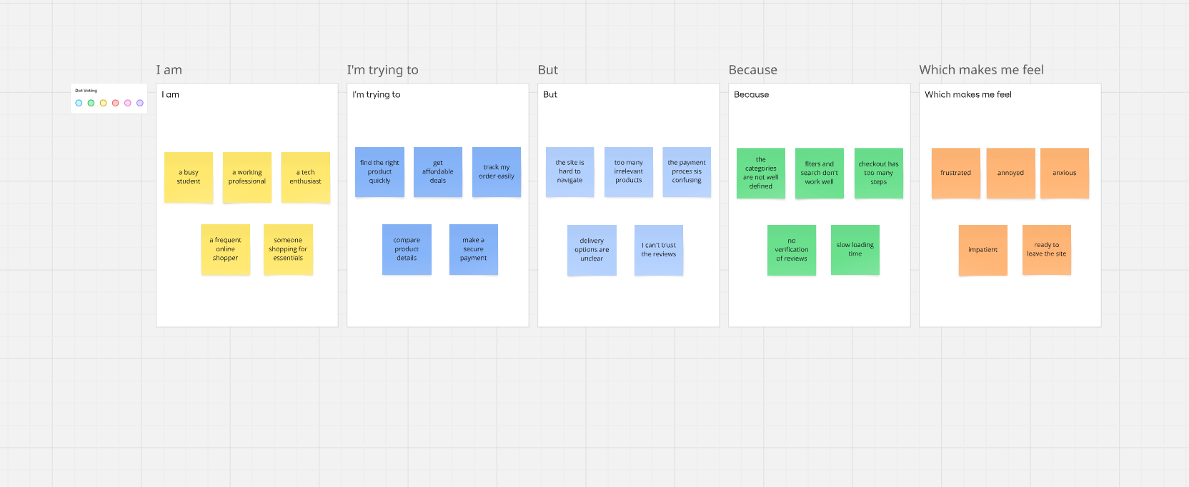

|  |  |  |  |  |  |
| --- | --- | --- | --- | --- | --- |
| **Problem Statement (PS)** | **I am (Customer)** | **I’m trying to** | **But** | **Because** | **Which makes me feel** |
| PS-1 | a busy student | find the right product quickly | the site is hard to navigate | the categories are not well defined | frustrated |
| PS-2 | a working professional | get affordable deals | too many irrelevant products | the filters and search don’t work well | annoyed |
| PS-3 | a tech enthusiast | track my order easily | the payment process is confusing | checkout has too many steps | anxious |
| PS-4 | a frequent online shopper | compare product details | delivery options are unclear | no verification of reviews | impatient |
| PS-5 | someone shopping for essentials | make a secure payment | I can’t trust the reviews | slow loading time | ready to leave the site |